Steps to Migrate from RelayHealth to Change Healthcare in Medisoft/Lytec’s Revenue Management

Effective July 1, 2018, Change Healthcare (formerly RelayHealth) is rebranding numerous products and services including the Electronic Mailbox Facility (EMF). Three items in particular are being changed that affect Medisoft and Lytec Revenue Management customers submitting files to RelayHealth:
- URL (Web address)
- infoExchangeClient.jar file
- Java Runtime Environment (JRE)
The URL for the EMF mailbox is being changed. The new URL is going to be: infoexchange.changehealthcare.com. A defect has been created so that this URL will be changed in a future Revenue Management update. The defect can only be fixed for the standard “RELAY” communication session. Anyone using copied and customized RELAY sessions will need to follow the below instructions to manually update the URL.
- In Revenue Management click on Configure then Communications

- In the Communications screen scroll down to the RELAY communication session (Or the copied RELAY session you’re actively using for your practice)

- Click on the Details column and the Web Address box will appear

- Remove the URL that is currently in the box and enter; https://infoexchange.changehealthcare.com. Then click OK, a browser will appear with the login screen for Change Healthcare. Close that browser to return to the Communications screen.

- Click Close, and when prompted to save changes click Yes.

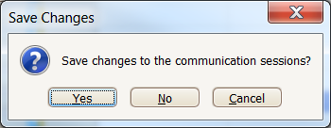

Change Healthcare is also updating the infoExchangeClient.jar file to version 3.1.1. It is important to update this .jar file as the old one will stop working after July 1, 2018 and files will not be received by Change Healthcare. Below are two options for downloading the new infoExchangeClient.jar file and instructions for configuring it for use with Revenue Management.

Option 1

For the first option a Collaboration Compass/Connect Center user ID and password is needed.
- Go to, https://www.collaborationcompass.com, and login using your Collaboration Compass/Connect Center user ID and password.

- Once logged in go to Support then Communication Options

- In the Communication Options screen click on the InfoExchange Client link under Software Downloads in the right portion of the screen. That will download the infoExchangeClient zip file to your download folder.

- Open the zip file and extract the infoExchangeClient.jar file to the RCM folder. For Medisoft the RCM folder is located in the Bin folder. For Lytec the RCM folder is located in the Lytec program folder. When prompted to confirm replacement of the existing file select Yes

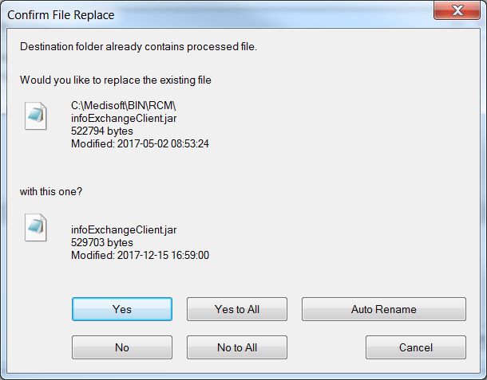

Option 2

For the second option you will need your EMF user ID and password.
- Go to, https://infoexchange.changehealthcare.com, and log in with your EMF user ID and password

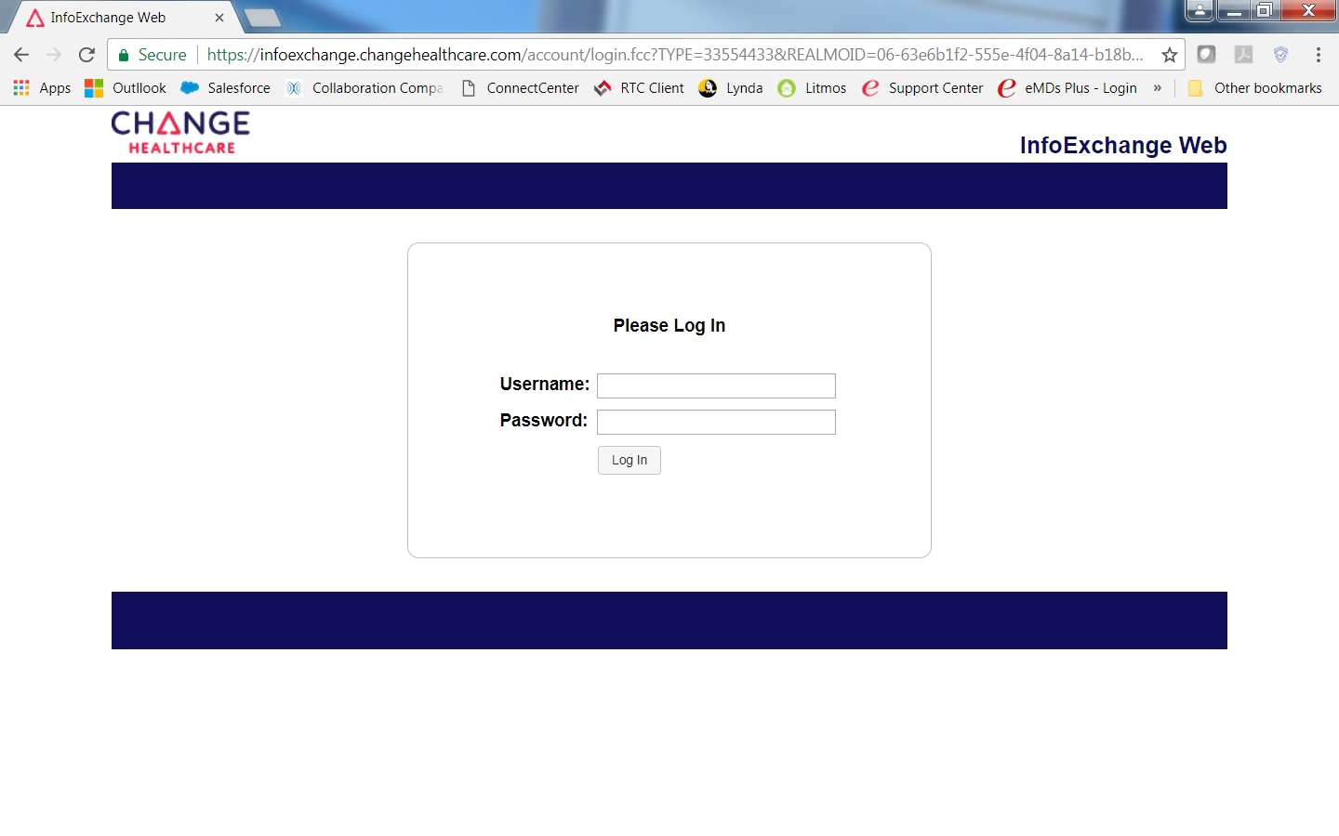
- Once logged in click on Downloads

- In the Download screen click on infoExchangeClient311.zip to highlight, then click on the Download button. That will download the infoExchangeClient311.zip file to your Download folder.

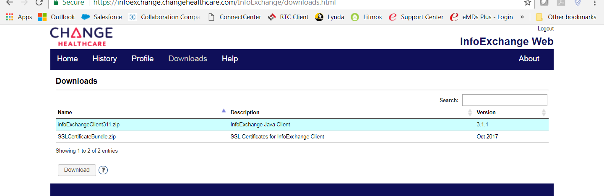

- Open the zip file and extract the infoExchangeClient.jar file to the RCM folder. For Medisoft the RCM folder is located in the Bin folder. For Lytec the RCM folder is located in the Lytec program folder. When prompted to confirm replacement of the existing file select Yes

NOTE: Additionally, the infoExchangeClient.jar version 3.1.1 file is attached to this KB article as well if you prefer to download it from here:
Medisoft: http://www.medisoft.com/RMPatches/IEC311/infoExchangeClient.jar
Lytec: http://www.lytec.com/RMPatches/IEC311/infoExchangeClient.jar
Change Healthcare also emphasizes that the Java version being used with the new infoExchangeClient.jar file must be version “8” or higher. The Java Runtime Environment (JRE) that ships with the Revenue Management program is currently version “6” meaning it needs to be manually updated. It is important to update the JRE folder as the older version is not compatible with the new .jar file and files will not be received by Change Healthcare.
1. Download the file labeled “JRE.zip” that is attached to this KB article and save it to your computer.
Download links: Medisoft: http://www.medisoft.com/RMPatches/JRE8/JRE.zip
Lytec: http://www.lytec.com/RMPatches/JRE8/JRE.zip
2. Once the file is downloaded, the contents of the JRE folder that is located in the RCM folder will need to be
manually deleted before trying update the JRE folder. For Medisoft, the RCM folder is in the bin folder of the
Medisoft program folder. For Lytec, the RCM folder is located in the Lytec program folder. Below is a screenshot
of the current JRE folder.
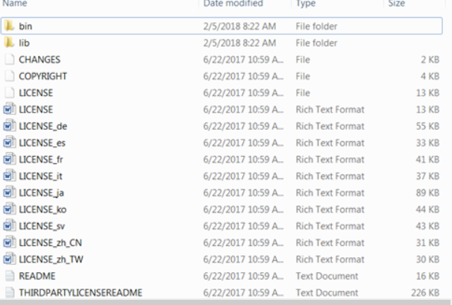

3. Start by deleting the bin folder in the JRE folder. Then try deleting the lib folder. You will probably
get a "Folder in Use" pop-up. If so, go into the lib folder and manually delete all files and folders.
There is a good chance that another folder in use pop-up will appear indicating the fonts folder.
Click on Cancel and go back to the original screen of the JRE folder and delete the remaining files.
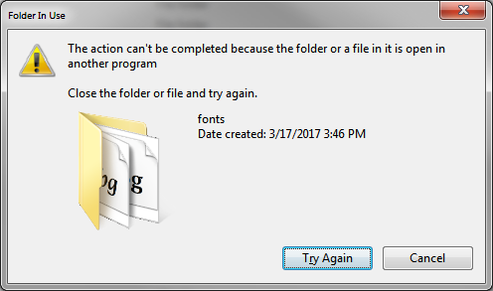

4. Now the JRE zip file that was downloaded can be extracted to the RCM folder. Below is a
screenshot of the JRE folder after the new version has been imported.
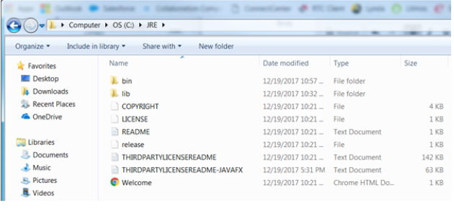

NOTE: The build of the Java Runtime Environment Revenue Management is specifically using with this KB article is version 8 build 162 x86 version (Released January 16, 2018). For advanced users, if you prefer to download and setup Java using files supplied directly by Oracle, you can download it from their website using the following links:
Downloads:
http://www.oracle.com/technetwork/java/javase/downloads/jre8-downloads-2133155.html
Direct link:
http://download.oracle.com/otn-pub/java/jdk/8u162-b12/0da788060d494f5095bf8624735fa2f1/jre-8u162-windows-i586.tar.gz

